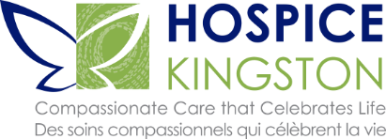

**SPONSORSHIP PROPOSAL**

For over 35 years Hospice Kingston has provided comfort, support and companionship to individuals with life-limiting illness, their families and caregivers, and those affected by grief and loss.

Hospice Kingston offers compassionate supportive care services, at no charge to our community, aimed at providing emotional, social and spiritual support. We are in the process of realizing our long-term goal to establish Kingston’s first 10-bed hospice residence and palliative care centre at Providence Village.

Hospice Kingston is steadfast in our commitment to raise funds to support our Community Hospice Services. We recognize it would not be possible without the collective commitment and financial support of our many donors, sponsors and volunteers.

**The following proposal outlines sponsorship opportunities and provides the benefits and corporate exposure Hospice Kingston is pleased to provide in return for your support.**

**Sponsorship Opportunities**

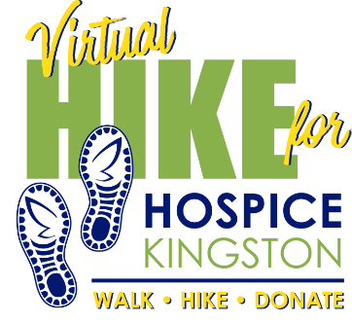 Hospice Kingston will join communities across Ontario and Canada to

raise funds, and awareness for Hospice Palliative Care and Community Services.

Participants will lace up their shoes or boots to hike, walk or run in memory of a loved one and raise money for our community.

**Event Date:** May 29 – June 13, 2021

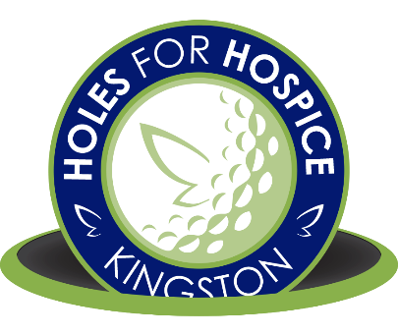**Virtual Holes for Hospice**

This much loved annual Golf Tournament in Memory of Larry Gibson is

***Celebrating its 10th Year.***

We are not able to host it in our traditional form however are encouraging our golf community to continue their support by playing a round when they want, where they want… safely.

**Event Date:** Summer 2021

An online auction in support of *Community Hospice Services.* Over 200 incredible items and experiences from local businesses.

**Auction Dates:** November - December 2021

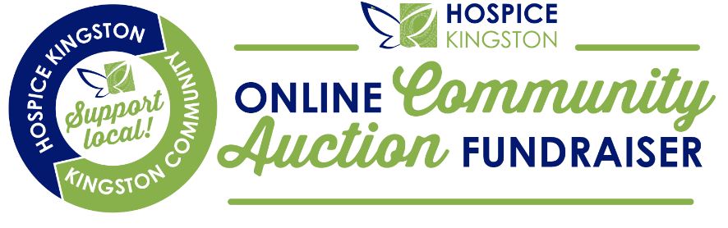



**Annual Mail Campaign**

Hospice Kingston’s Annual Campaign letter, profiling a client and volunteer, and services we provide, is mailed, emailed, and promoted on social media leading up to Giving Tuesday and during the “Season of Giving”.

**Mail/Promotion Dates:** November - December, 2021

**Create Your Own Sponsorship Package**

Sponsorship packages can range from $500 - $10,000. We can create a package that meets your marketing objectives, business demographics, and budget.

Sponsor your favourite event or put your name in front of a new audience and increase your

market share by sponsoring several events and fundraising and awareness initiatives.

Communicate your message and demonstrate your social responsibility

values to your clients and community.

**Recognizing Your Sponsorship**

Hospice Kingston is committed to providing value to our partners and sponsors by maximizing the return on investment you make with us.

Hospice Kingston would like to offerthe following benefits in exchange for your support this year:

* Prominent recognition as sponsor on event portal
* Logo/Name on all event posters and materials
* Logo/Name on all pre/post print media promotions
* Promotion on our Social Media channels
* Acknowledgement and recognition on our website, quarterly newsletters and *Annual Report to the Community*

We would appreciate the opportunity to work with you to create a partnership that provides added value to both parties and are open to discussing the various benefits we can offer.

**Thank You**

We are grateful for your consideration of this sponsorship request and look forward to working with and celebrating your support.

Your support will help us continue to provide Community Hospice Services at no charge to individuals in our community.